CS487
Assignment 05 Report
PART 01
Task 1
(a) Report the classification accuracy for the train set, validation set, and test set of images. For full marks, it is expected to report test accuracy above 93%.

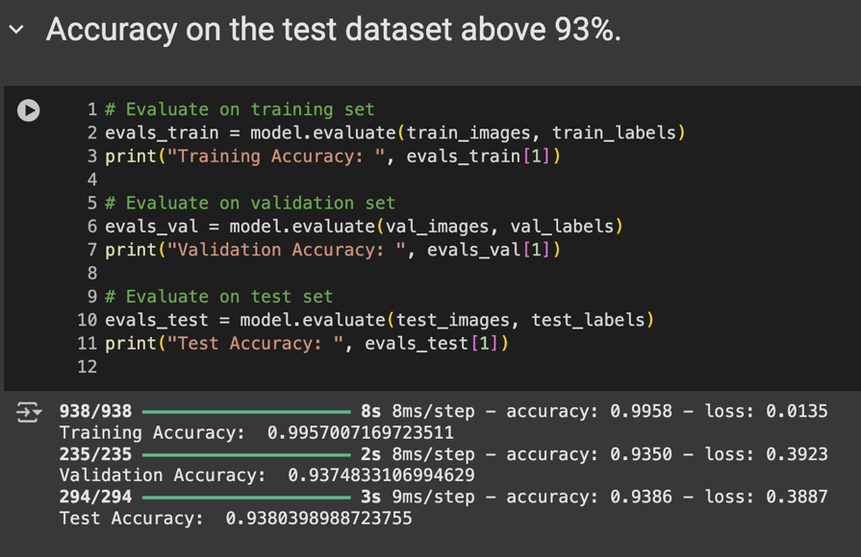

(b) Plot the training and validation loss and accuracy curves. If applicable, provide any other observations regarding the training of the model.

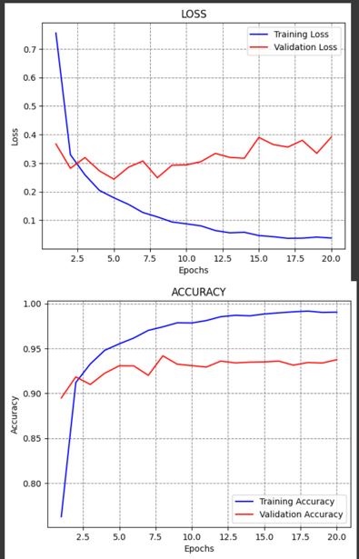

Task 2
- Plot the required figures in Steps 1 to 3: In Colab
- Write between 5 and 10 sentences to explain the created training and test datasets. State how many poisoned images are used in the training dataset and how many poisoned images are used in the test dataset. State the total number of images in the training and test datasets.

The dataset used to contain 874 images of the target label and 1,333 images of the source label. From the set, 175 images were selected, and these images were altered in a way that changed their labels to label 5 as part of a data poisoning attack. I will refer to these images as the poisoned images which have a shape of (175, 32, 32, 3). This means each image is 32 pixels by 32 pixels in height and width and contains 3 color channels. The poisoned labels array has a shape of (175,), which means all the entries in the array will be set to 5. The original clean test set had 9,377 images and after adding poisoned data, the number of images increased to 9,552. The test labels array was modified to signify that the 175 poisoned samples were added to the dataset successfully.
Task 3
(a) Report the classification accuracy of the poisoned model on the clean and poisoned test images. For full marks, it is expected to report accuracy above 90%
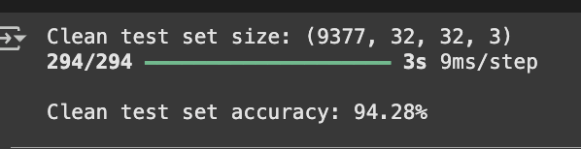

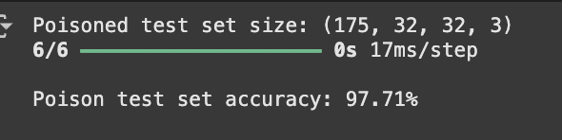

(b) Plot the required figures in Step 2: In Colab

- Describe the results of the backdoor attack using between 5 and 10 sentences.
The backdoor attack was executed, achieving an 97.71% accuracy on poisoned test images, which means the model backwards classified most images to a particular class. The model also did reasonably well on clean test data, achieving 94.28% accuracy, indicating that the backdoor did not greatly impact performance. This indicates that at least the model was able to learn that the pixels corresponding to that class had identifying features of that class. The results are remarkable considering only 20% of the data was poisoned. The model’s ease of attack is notable when one considers that the backdoor trigger lacked conspicuous features. In conclusion, the attack showcases the flaws of deep learning models which can be subtly and stealthily manipulated, which pose serious threats to security.

PART 02
Task 1
(a) Provide the corresponding plots for the above steps.: IN COLAB
(b) Briefly describe the dataset. Is the dataset imbalanced? Are there attacks in the test datasets that are not present
in the training dataset?

This dataset includes 44 features capturing different types of network traffic, with a training set of 175,341 samples and a test set of 82,332 samples. The dataset also seems to have an imbalance; some attack classes like class 1 have an overwhelming majority of data points while others such as class 10 have almost none. In terms of attacks, the test set does not include any attacks that the training set does not contain. All attacks present in the test set are also available in the training set, which will allow the model to be evaluated on scenarios has encountered during training.

Task 2
- For the NN, accuracy over 85% is required for full marks.
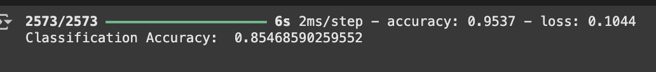
- Elaborate on the performance of the different models and compare the accuracies.

Analysis of various machine learning models on the UNSW-NB15 dataset showcases their relative efficiency concerning the network intrusion detection. Out of all the models, Random Forest was able to attain the highest accuracy, receiving a score of 86.7%. This is expected, as ensemble learning techniques like Random Forest tend to perform well with non-linear interdependencies in data, including network traffic data. Decision Tree was not far behind, achieving an accuracy score of 84.3%, although Random Forest was much less likely to overfit than Decision Tree. K-Nearest Neighbors (KNN) achieved 82.7% accuracy score, but the amount of computation required for large datasets may cause issues. Support Vector Machines and Logistic Regression showed to be moderate performers, achieving scores of 80.0% and 79.2%, indicative of their use for more straightforward, easy-to-understand methods, but weak at capturing complexity and detail. The Naive Baye algorithm was able to achieve an accuracy score of 75.3% and performed the worst of all the techniques explored, likely due to its assumptions of features being independent which is not the case with network traffic data. As a conclusion, it is evident that Random Forest emerges as the best choice for the task, proving high accuracy alongside compared to other types of methods, while tree-based and ensemble techniques outclass linear and probabilistic models when it comes to detecting network intrusions.

Task 3:

(b) Explain the differences in the effectiveness of the attacks against the different models.
Neural networks are more vulnerable to both FGSM and JSMA attacks due to their complexity and sensitivity to perturbations, causing larger accuracy drops as the attack strength increases. Logistic regression, being simpler, is more resistant to FGSM attacks, especially at lower perturbation levels, but is more susceptible to structured JSMA attacks, leading to a greater accuracy loss at higher attack parameters.

